1) First select Calculus online Transactional → Ho payment Process →ST Update

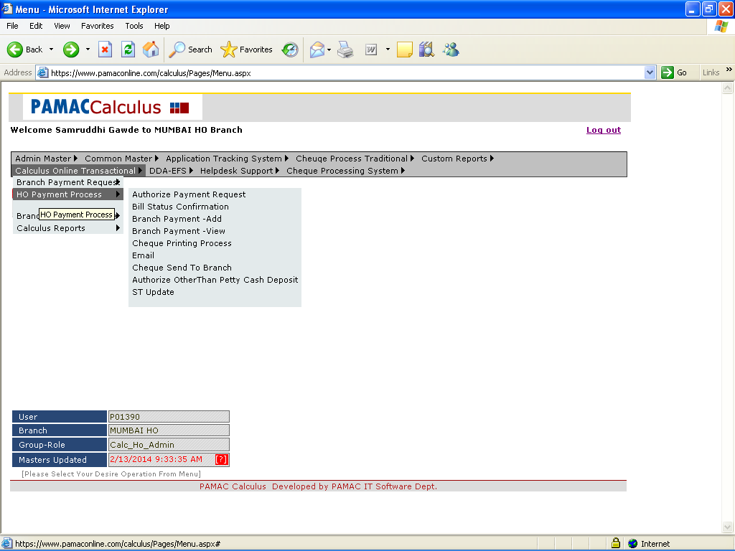

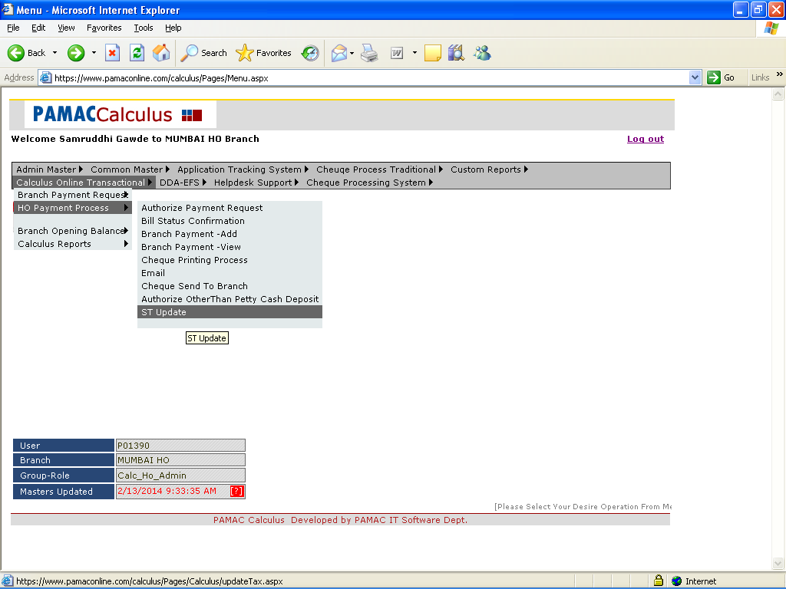

2) Update tax form
Enter all detail as per the bill transaction

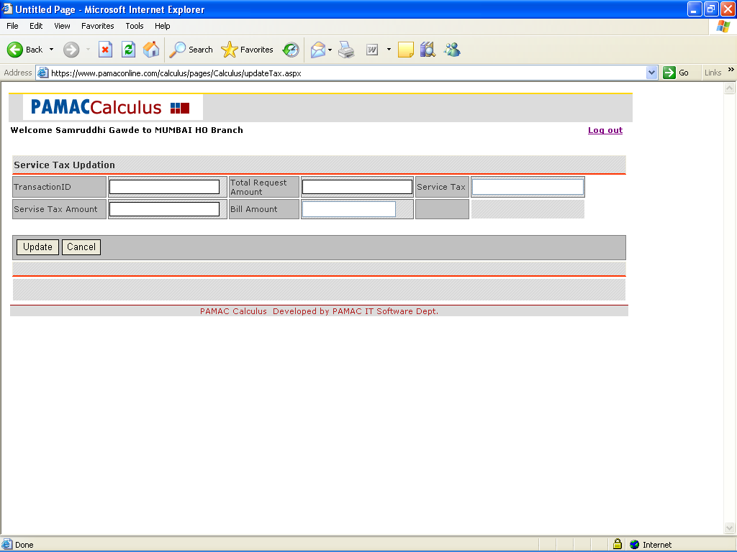

3) After inserting data click update option for update Bill Transaction

